Report on Smart Library Management System

Name: Abdullah Javed
ID: F2023065162
Section: W8
Resource Person: Bilal Arif
Subject: Software Construction & Development

Class Diagram of SLMS
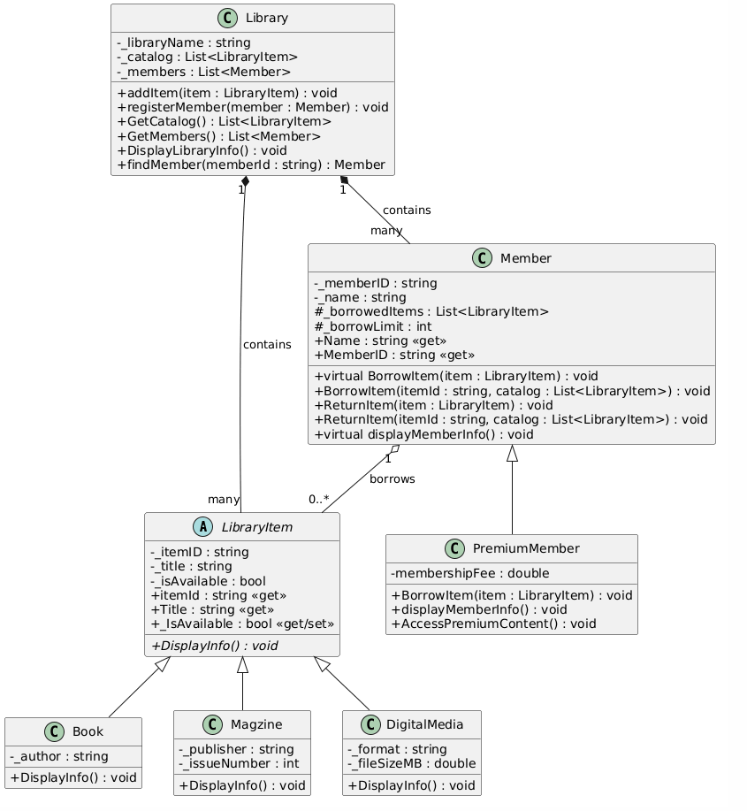

Development Approach
The project followed a Domain-Driven Design (DDD) approach within an Object-Oriented Programming (OOP) framework. The core focus was on creating a flexible system that treats different types of media as a unified entity while allowing for specialized behavior.

Key Architectural Decisions:
- Abstraction & Generalization: By using an abstract LibraryItem class, the system follows the Open/Closed Principle. We can add new media types (e.g., Audiobooks) without modifying the Library or Member classes.
- Polymorphism: The DisplayInfo and BorrowItem methods are overridden in derived classes. This allows the system to treat a PremiumMember and a standard Member the same way in the code, but execute different logic (e.g., higher borrow limits) at runtime.
- Encapsulation: Sensitive data like _isAvailable and _borrowedItems are kept private or protected, ensuring that the state of the library can only be modified through controlled methods.
- Seeding Mechanism: To ensure immediate usability, the system utilizes a seeding approach in the Main method, populating the catalog with regional and international titles.

AI Assistance & Research (R&D)
During the development of this project, AI was utilized as a collaborative partner to optimize code structure and ensure best practices.

Areas of AI Contribution:
- Refactoring & Simplification: Originally, separate classes might have been planned for various digital formats (like DVDs). AI suggested a more efficient approach: using a single DigitalMedia class with a _format property to handle PDFs, DVDs, and other files, reducing code redundancy.
- Logic Verification: AI helped in refining the "Borrow/Return" logic—specifically in handling method overloading. For instance, providing one version of BorrowItem that takes an object and another that takes an ID string to make the UI implementation cleaner.
- Cultural Contextualization: AI assisted in providing relevant "Reference Data." For example, suggesting Pakistani-centric titles like "Aangan" by Qurratulain Hyder or films like "Waar" to make the library feel more "Smart Community" oriented rather than just a generic template.
- Diagram Mapping: AI was used to parse the C# syntax and translate the relationships (Inheritance vs. Composition) into PlantUML syntax accurately.

Important Takeaways:
Note on Member Logic: A key R&D finding was the necessity of the virtual keyword. Without it, the PremiumMember's specific borrow limits would be ignored when stored in a List<Member>. This is a classic example of Runtime Polymorphism that AI helped debug.

References
This research and development process was supported by a multi-model AI workflow, leveraging specialized tools to ensure code quality, architectural integrity, and professional documentation.

AI Tools Utilized:
- Gemini (Google): Used for high-level conceptual mapping, R&D report structuring, and the generation of PlantUML syntax for visual modeling.
- Claude (Anthropic): Assisted in deep-code refactoring, optimizing the Object-Oriented hierarchy, and ensuring adherence to SOLID principles (specifically the Open/Closed Principle).
- GitHub Copilot: Employed as a real-time pair programmer for autocomplete logic, syntax debugging, and boilerplate generation within the Integrated Development Environment (IDE).

Documentation & Knowledge Bases:
The AI models cross-referenced the following technical documentation to assist in the development of this system:
- Microsoft .NET Documentation: Specifically for System.Collections.Generic (List management) and C# Inheritance/Polymorphism standards.
- C# Programming Guide: For implementing abstract classes, virtual methods, and method overloading.
- PlantUML Language Reference: To ensure the class diagram code is compatible with standard rendering engines.
- OOP Design Pattern Repositories: For implementing the "Strategy-lite" approach in handling different member borrowing limits.

